Level 3 -> Level 4

The goal of this level is to find out the hidden file in the **inhere** directory and get the password of next level.

So now, firstly we will check the files and folders of the current directory in which we are by using **ls** command. Simple **ls** command is used to list out all the files and folder of the directory in which the user is present. A directory named **inhere** is present in the current directory in which we are. We will jump into this directory using **cd** command.

Again, using ls command, we will check files and directories present in inhere directory. But simple ls command will not display the hidden files or folders. Hidden file’s name starts with **.(dot),** like- **.hidden**

Now we will use **ls --help** command to find out an option to use with ls so that we can display hidden files also. **-a** option is there for us to display all the files and also does not ignore the files starting with **.**

When we run **ls -a** command it lists the name of all files including hidden files present. We found the required file i.e. **.hidden** .

We can read the content of the hidden file by simply using **cat** command.The file contains the password for level 4.

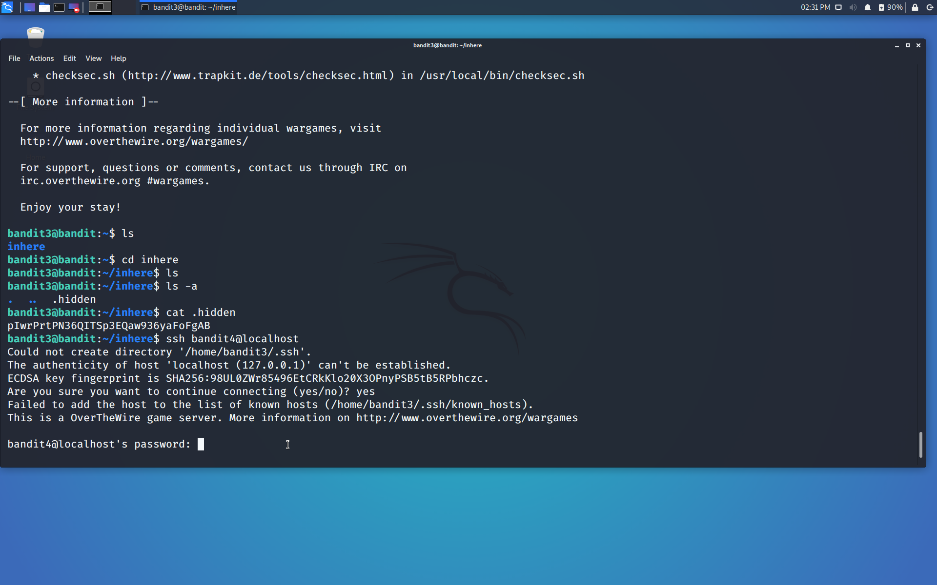

Use the command **ssh bandit4@localhost** to connect to the level 4.

Enter the password and hit enter.

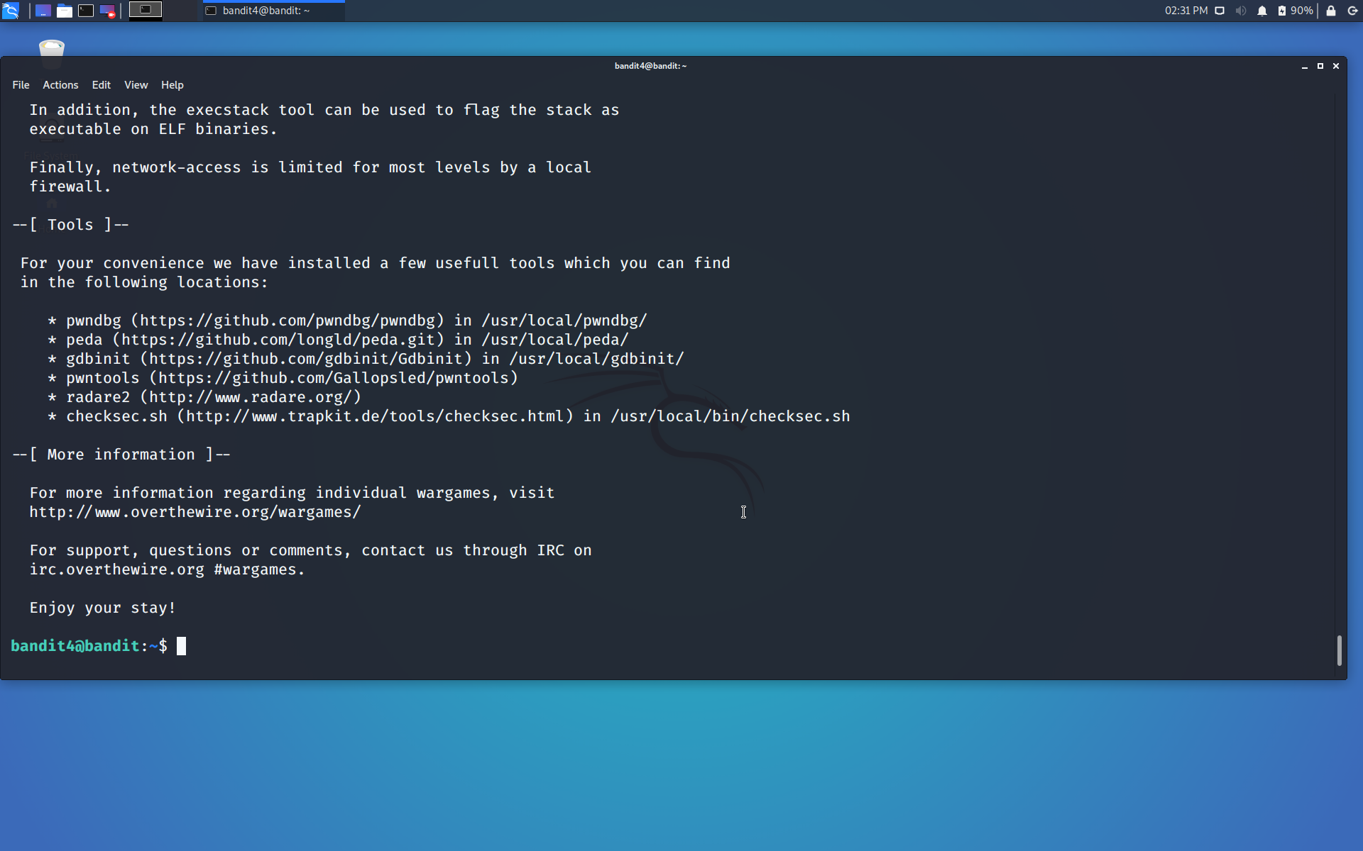

Successfully passed level 4.…